EVENT BOOKINGS INSTRUCTIONS FOR NON -IIRRT MEMBERS
1.Log into Homepage - Irish Institute of Radiography and Radiation Therapy (iirrt.ie)
2. After logging into the homepage of the IIRRT website please select CPD STUDY DAYS /SURVEYS

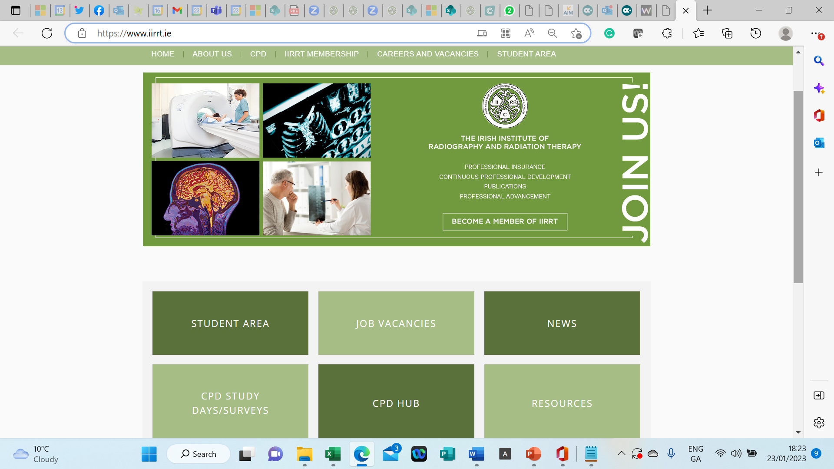
3.You come to this screen , select the CPD event you wish to book
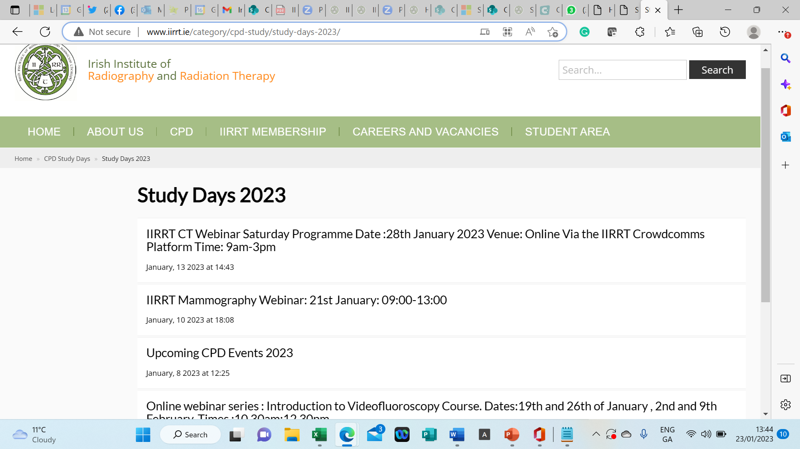
4.You will then come to the event details, scroll down to the bottom of this page, and select
BOOK HERE
5. You will then come to this screen, select EVENTS in the top menu bar
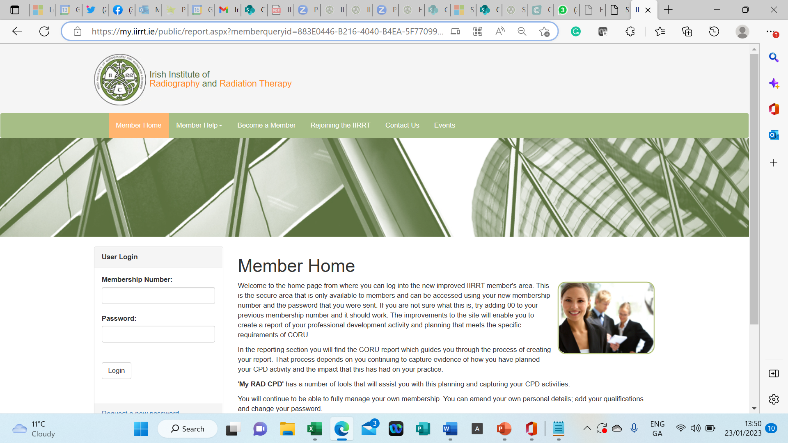
6.You will come to the following page, scroll again to the event you wish to book and choose
VIEW DETAILS

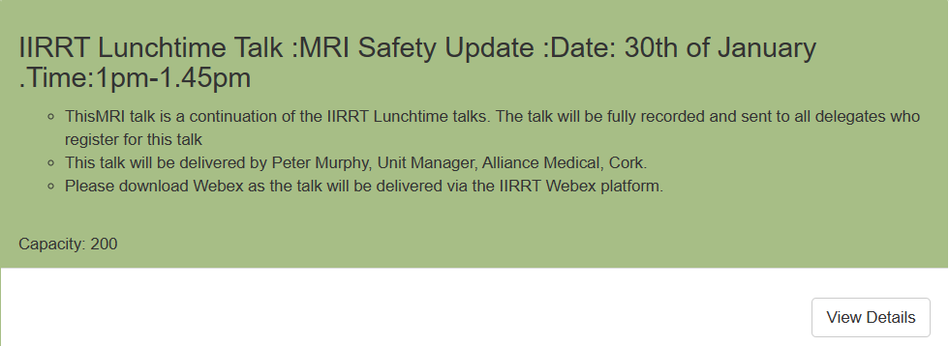
7.You then come to the following page, scroll down to ADD CART

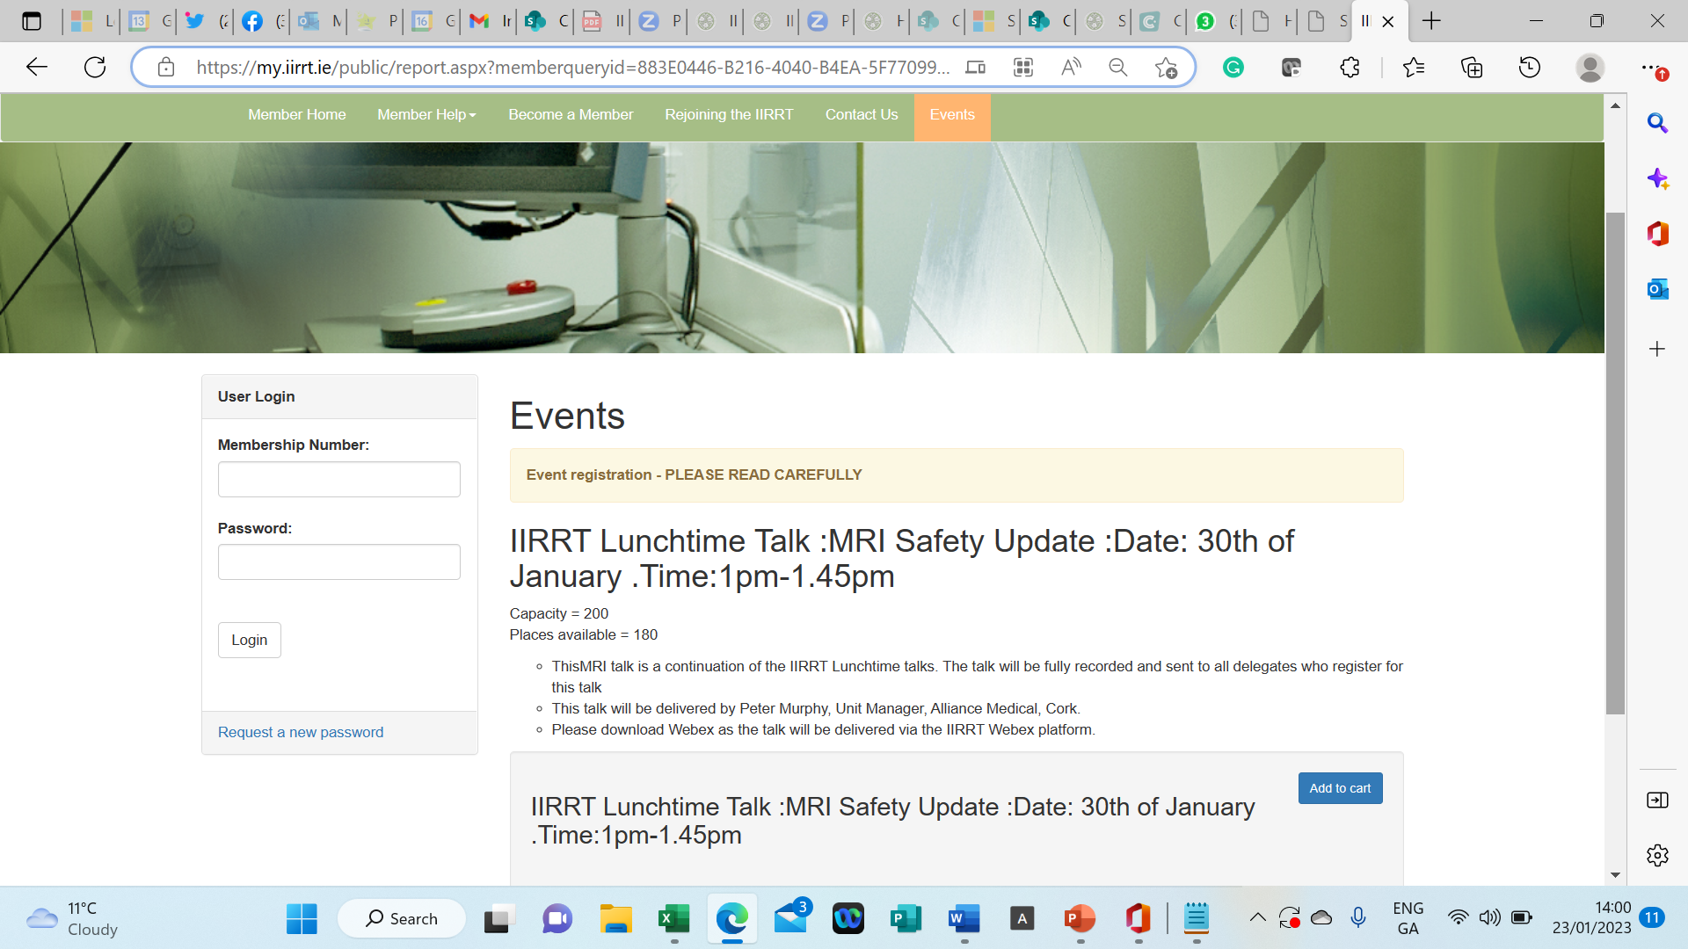
8. Next select the SHOPPING CART in top right-hand corner

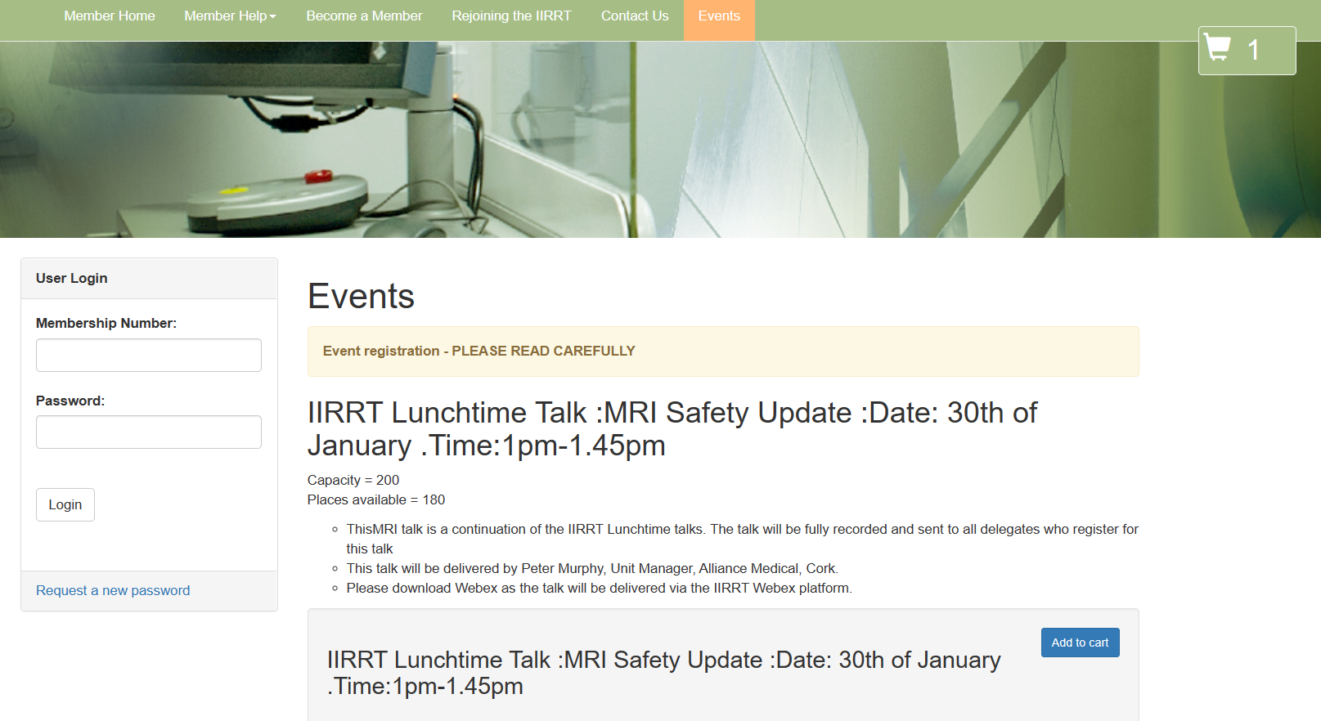
9.Enter your personal booking details here as required and select CONTINUE
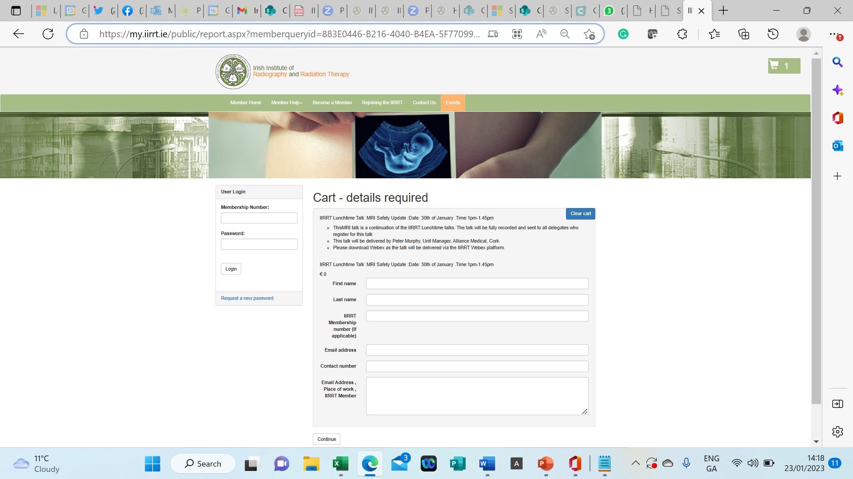
10.Next, you should come to the following page to confirm that your booking is now complete
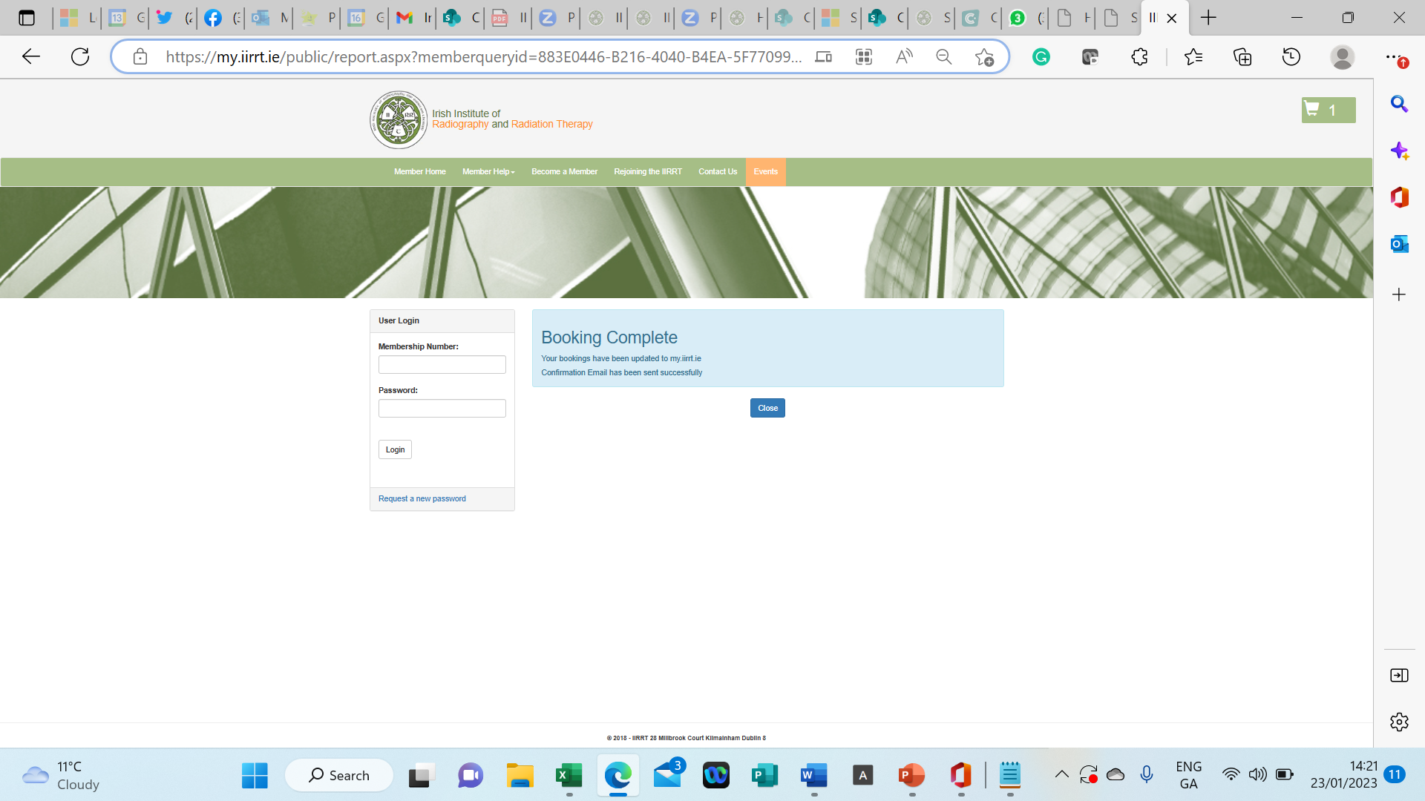
11.You should receive an email with confirmation of registration and of payment for the booked event like the example below to the email you registered with (please note that this email may go to your spam folder).
